**Name:________________________ Per:______**

Unit 9 Outline- Solutions, Acids & Bases

**Essential Skills/ State Standards:**

1. Describe the dissolving process at the molecular level between different types of substances:

* Polar, non-polar, and ionic
* Understand how some solutions become electrolytes

1. Calculate the concentration of a solution in terms of molarity
2. Explain the different properties of acids & bases by:
   * Identifying acids and bases using laboratory equipment
   * Using the pH scale to characterize acid and base solutions.
   * Diagramming the way strong acids/ bases differ from weak acids/ bases
   * Writing neutralization reactions

**Study Guide (Use notes, worksheets, and labs in addition to this study guide)**

1. 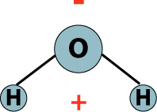Water is **polar**- draw a picture that demonstrates your understanding of this concept.

Polar- which means it has (+) & (-) ends to the molecule because oxygen hogs the electrons it shares with hydrogen.

1. a. Explain why the **polarity** of water allows it to be such a good solvent.

anything that is charged that is put in H2O will be attracted to it.

ex. Ionic compounds…aka salts

Also, other polar substances…aka sugars.

b. What types of bonded substances (ionic, polar covalent, non polar covalent) dissolve easily in water?

Ionic & polar covalent

1. Complete the following chart:

|  |  |  |  |  |  |
| --- | --- | --- | --- | --- | --- |
|  | KBr | C3H8 | C6H12O6 | HCl | NaOH |
| Bond type | Ionic | Non polar covalent | Polar covalent | Really polar covalent (Acid) | Ionic  (base) |
| Draw image that shows on the **MOLECULAR LEVEL** how each of these would dissolve in water | H2O surrounds the K+ and Br- and separate them from each other. | They do not mix… “like dissolves like” and they are not like each other. | water surrounds the polar sugar, but does not cause it to break apart. | H2O surrounds the H+ and Cl- and separate them from each other. | H2O surrounds the Na+ and OH- and separate them from each other. |
| Electrolytes? Explain. | Yes, charged ions will conduct electricity | No, they do not conduct electricity. | No, generally polar molecules do not dissociate in water. | Yes, charged ions will conduct electricity | Yes, charged ions will conduct electricity |
| A/B/N? | Neutral | Neutral | Neutral | Strong Acid | Strong Base |

1. Given 16 g of sulfur dissolved in 250 mL of water calculate the molarity.

M = mole/ liter

a) determine moles: 16 g x 1 mol/ 32 g = .5 mole

b) plug into equation: M = .5 mole/ .25 L

c) solve: M= 2 M

1. You need to make 500 mL of a 2M sulfur solution. How many grams of sulfur would you need to add to the water?

M = mole/ liter

a) plug into equation: 2M = X / .5 L

b) solve: X= 1 mole S

c) determine grams: 1 mol S x 32 g/ 1 mole = 32 grams

1. Identify the following substance as an acid or a base based on the following characteristics:
   1. reacts with Zn to form H2 gas bubbles Acid
   2. pH= 9 base
   3. pH= 1 Acid
   4. conducts electricity acids & bases
   5. turns phenolphthalein pink base
   6. turns ph/ litmus paper blue base
   7. turns ph/ litmus paper red Acid
2. **Identify** the compound as an acid or base & explain how you’ d know:
   1. H2SO4 + H2O🡪 H3O + + HSO4-
   2. NH3 + H2O 🡪 OH- + NH4+

Acid because of H3O Base because of OH-

1. **Write** how the following would dissociate in H2O ***&*** determine if they are an **acid** or **base**:

HNO3  🡪 🡪 H+ + NO3-

KOH 🡪 K+  + (OH)

Acid because of H+ Base because of the (OH)-

1. Draw a pH scale with the correct numbers **and** label where you’d find strong bases, weak bases, strong acids, weak acids, and neutral substances.

*strong acids *Neutral *Strong bases

0 weak acids 7 weak bases 14

1. How does a **strong** acid/ base differ from a **weak** acid/ base?
   * Strong acids and bases dissociate (break apart) a very high %
   * Weak acids/bases = do not break apart very often

See picture which shows a strong (left) vs. weak (right)

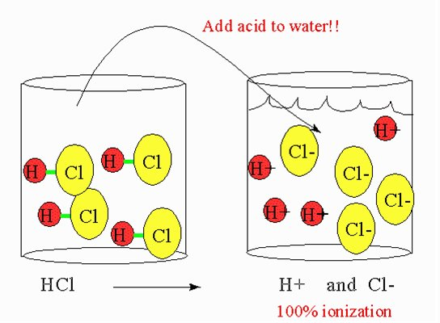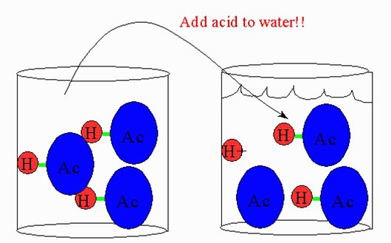

1. A) Write the products of the following reaction: KOH + HNO3 🡪 K+ + NO3- + H2O

(an ionic salt + water)

1. What special type of double replacement reaction is this?

neutralization

1. Would this solution conduct electricity? How do you know?

Yes, because the salt that is created will break apart in water into its ions. Charged ions conduct electricity.

1. Explain how to **neutralize** an acidic solution.

Add enough base until all the OH- ions cancel out the H+ ions and water is formed.